Worksheet 10.5

The ten best songs, ever!
Student: Class:

Leadership styles
Conduct an experiment investigating the
effectiveness of leadership style. Participants should be randomly placed into one of three groups. Appoint a leader for each group. The leader should choose one of the following three leadership styles that they will adopt but must not inform the rest of the group.
(a) An autocratic leader (pushy, insists that group only do as asked, won’t listen to others’ points of view, demanding)
(b) A democratic leader (listens to every member of the group, encourages participants to succeed and participate, firm but friendly, participates in group activity)
(c) A laissez-faire leader (easygoing, does not push, does not take any control of the group, passes control on to someone else)
Each group is to come up with a list, in any order, of the all-time best 10 songs according to the group.
The groups should be given 15 minutes to complete the task.
Rate each group member’s happiness with the list of songs by placing a tick in the square that most represents how each group member feels about the list. Choose a speaker to report the findings to the group. Discuss which leadership style seems to be the most effective in completing this task.

1.  Very unhappy | 2. | 3. | 4. | 5.  Moderately happy | 6. | 7. | 8. | 9. | 10.  Very happy

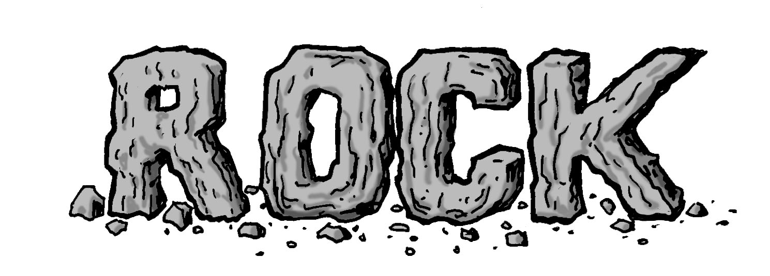 | 1.  2.  3.  4.  5.  6.  7.  8.  9.  10. | 
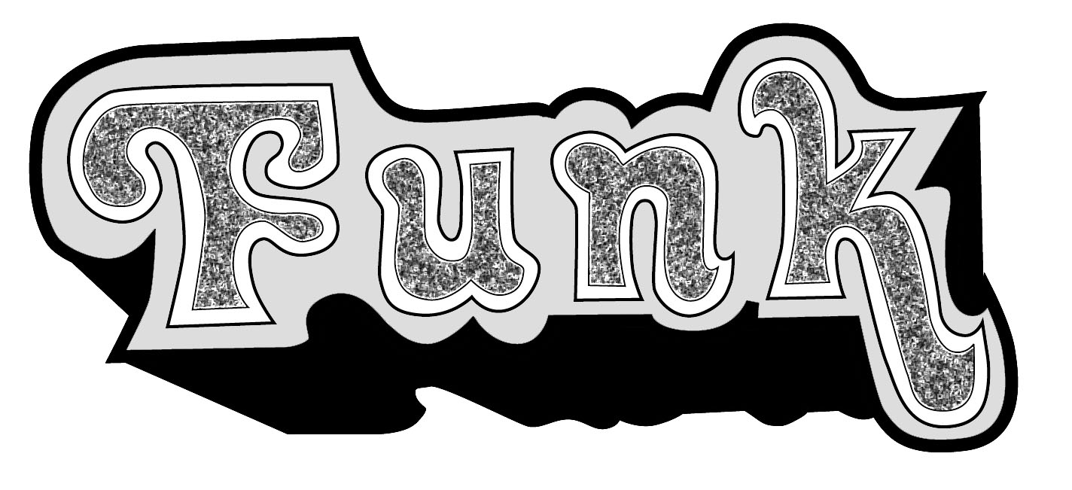 | 1.  2.  3.  4.  5.  6.  7.  8.  9.  10. | 
 | 1.  2.  3.  4.  5.  6.  7.  8.  9.  10. | 
 | 1.  2.  3.  4.  5.  6.  7.  8.  9.  10. | 
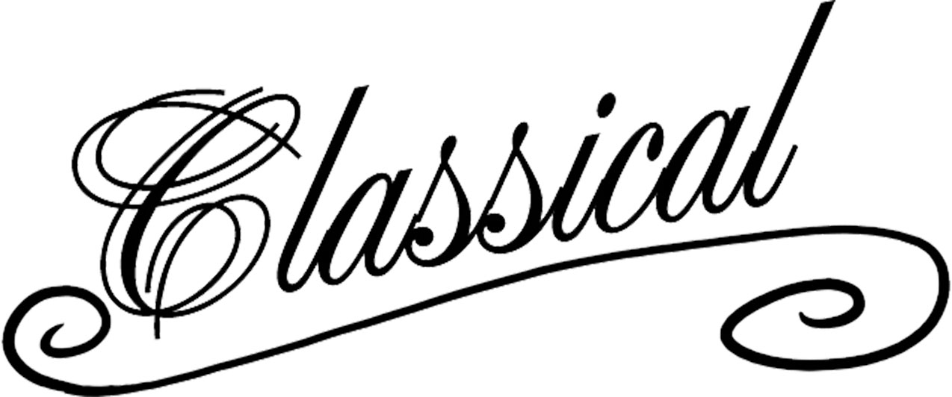 | 1.  2.  3.  4.  5.  6.  7.  8.  9.  10. | 

